

LOCAL ROADS CONNECTIVITY PROJECT


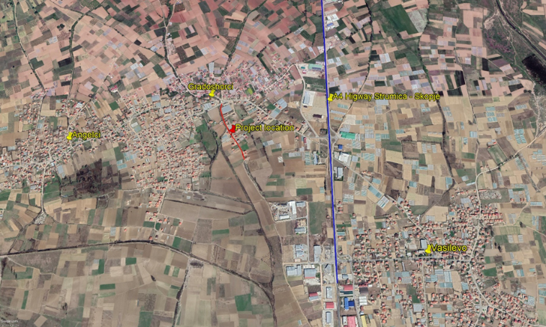
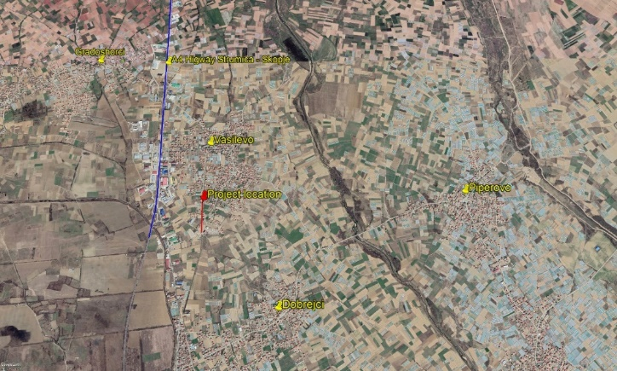

ENVIRONMENTAL AND SOCIAL MANAGEMENT PLAN (ESMP) CHECKLIST

Rehabilitation of existing local streets, in s.“Gradasorci” and in “Vasilevo” Municipality of Vasilevo

September 2020

Prepared by:
Slavjanka Pejchinovska-Andonova, MSc, Environmental Engineer
Environmental and Social (E&S) Specialist

Contents
1. Introduction 3
2. Environmental Category 3
3. Potential Environmental Impacts 4
4. Purpose of the Checklist ESMP 5
5. Application of the Checklist ESMP 6
6. Grievance Mechanism 6
7. Monitoring and reporting 8
ANNEX I: Checklist ESMP for the rehabilitation works 9
ANNEX II: Sites Description 30
ANNEX III: Report of the site visit of the reconstruction of the local streets in in s.“Gradasorci” and in s.“Vasilevo” 33
ANNEX IV: COVID-19 considerations in construction/civil works projects 36
ANNEX V: Form for submitting comments 41
ANNEX VI: Grievance Form for whole project implementation period 42

IMAGES
Figure 1 Location of the rehabilitation of the streets in Municipality of Vasilevo in s. “Gradasorci” 32
Figure 2 Location of the rehabilitation of the streets in Municipality of Vasilev, city of Vasilevo 32

ANNEXES
ANNEX I: Checklist ESMP for the rehabilitation works 9
ANNEX II: Sites Description 30
ANNEX III: Report of the site visit of the reconstruction of the local streets in in s.“Gradasorci” and in s.“Vasilevo” 33
ANNEX IV: COVID-19 considerations in construction/civil works projects 36
ANNEX V: Form for submitting comments 41
ANNEX VI: Grievance Form for whole project implementation period 42

ABBREVIATIONS
E&S | Environmental and Social
EIA | Environmental Impact Assessment
ESF | Environmental and Social Framework
ESMF | Environmental and Social Management Framework
ESMP | Environmental and Social Management Plan
ESS | Environmental and Social Standards
EU | European Union
H&S | Health and Safety
IBA | Important Bird Area
LRCP | Local Roads Connectivity Project
MOSHA | Macedonian Occupational Safety And Health Association
MSDS | Material Safety Data Sheets
MTC | Ministry of Transport and Connection
OH&S | Occupational Health and Safety
PIU | Project Implementation Unit
PPE | Personal Protective Equipment
RM | Republic of Macedonia
RNM | Republic of North Macedonia
WB | World Bank
WHO | World Health Organization

Introduction
The road infrastructure in the Republic of North Macedonia consists of national, regional and local roads where approximately 65% of the total length of all roads are local roads. National and regional roads are under the competences of the institutions and enterprises at the national level, while for the local roads infrastructure the competences are under the local authorities.
The local roads network is in poor condition, as a result of unsatisfactory road maintenance due to non-existent financing mainly because of weakness of international investment in the transport and distribution sector etc. As the main reason for the bad condition of the roads is that, every Region of the Republic of North Macedonia manages with different financial capacities that renders some Regions with not enough finances to upgrade/rehabilitate the existing roads leading to hospitals, schools and markets so this issue brings social problems as well.
For the purpose of rehabilitation of existing local road infrastructure (urban / rural streets, regional and local roads), pedestrian paths, street lighting, water drainage and capacity building of the municipal staff, 70 million Euro investment secured by the World Bank, will be invested through the Ministry of transport and communications by implementation of the Local Roads Connectivity Project (LRCP).

Environmental Category
For addressing the potential environmental and social concerns of the Project the Environmental and Social Management Framework (ESMF) will be prepared (as part of the LRCP of the MTC) in October 2019, by the Environmental and Social (E&S) Specialist which is in accordance with the requirements of the World Bank. The ESMF represents a tool for implementation of Environmental and Social Assessments and Management of Project’s compliance with Environmental and Social Framework (ESF) Standards, which allows conducting of an in-depth analysis of the environmental and social issues.
Preliminary screening according to the World Bank risk classification identifies two risk categories of the sub-projects: with substantial risk or with moderate risk for which different due diligence instruments need to be prepared.
“Projects with substantial risk” require sites-specific ESMPs, which should include sites-specific information with mitigation measures and monitoring plan.
“Projects with moderate risk” require preparation of the ESMP Checklist that identify potential environmental improvement opportunities and recommend measures for the prevention, minimization and mitigation of adverse environmental and social impacts.
Sub project environmental screening table for LRCP Project.
Types project activities | Environmental Assessment documents required | Applicable to:
1 | Environmental and Social Management Plans (ESMP) for each individual upgrading (sub-project) | Upgrading work of the local roads (intervention into the road body, structure, in addition to substituting of the pavement whereby upgrade works will intervene in reinforcing of the road body and installing of new pavements)
2 | ESMP Checklist | Rehabilitation of the existing local roads/streets (improving the condition of the road without changing the basic functional characteristics – changing of the asphalt layer and substitution with the new layer, re-pavement, pothole repairing, patching and any other road surface fixing, etc.)

Potential Environmental Impacts
From the implementation of the LRCP potential risks and impacts of the smaller scale sub-projects are expected to be temporary and/or reversible; low in magnitude and typical. These impacts are related to:
- dust nuisance and gaseous emissions,
- potential pollution of soil and water resources (accidental spillage of machine oil, lubricants, fuel, etc…),
- generation of different types of non - hazardous waste as well as small amounts of hazardous waste,
- noise and vibrations,
- brief disturbance to biotope,
- possible temporary disruption of current traffic circulation,
- traffic safety,
- occupational health and safety (OHS),
- localized disturbance of soil and impacts to water,
- construction of access roads and/or damage to access roads,
- temporary land usage if needed.
For this sub – project land acquisition is not envisaged as the property of the land where the local road/street is located is state owned. For the needs of the Contractor for temporary placement of machinery and equipment at a location in the immediate vicinity to the project that is privately owned (if there is a need), it is necessary to sign a Contract with the owner of the parcel for temporary land usage during project implementation period. The Contract will define terms and obligations for land usage or other premises (ex. garage, storage area, etc...) in line with the Project RPF Furthermore, all compensation will be paid before the respective land is accessed.
The situation at the project location before the start of the project activities is presented in the Site visit Report on 06.06.2019 which is shown in ANNEX III.

Purpose of the Checklist ESMP
ESMP checklist will be used for the projects for rehabilitation of the local roads - plain, less risky sub projects that usually only involve change of asphalt or drainage on exiting road. ESMP checklist provides “pragmatic good practice” and it is designed to be user friendly and compatible with WB ESF standards. This document will help assess potential environmental impacts associated with the proposed sub-project, identify potential environmental improvement opportunities and recommend measures for to the prevention, minimization and mitigation of adverse environmental and social impacts.
ESMP Checklist is a document prepared and owned by beneficiary. The design and implementation process envisaged for the subproject will be conducted in three phases:
- General identification and scoping phase, in which the rehabilitation of the road works that need to be carried out. At this stage potential negative/adverse impacts of the works to be carried out can be identified. Parts 1, 2 and 3 are drafted. The second part of the ESMP Checklist contains all of the typical activities and associated typical environmental issues and appropriate mitigation measures.
Considering the current situation with COVID 19, in addition to the measures for safety and protection at work, the plan also includes measures for prevention of COVID 19. The CОVID 19 prevention measures contains recommendations from the World Bank / WHO, as well as recommendations from the Macedonian Occupational Safety and Health Association in the form of a Guide that the Contractor of the construction works needs to implement. The Contractor is required to follow/update and implement the measures that are currently in force and adopted by the Government as binding at national level. Оfficial site for information related to COVID 19 on national level is www.koronavirus.gov.mk.
Detailed description of the measures and recommendations from the World Bank/WHO and MOSHA are presented in ANNEX IV.
2) This phase covers project specifications and the bill of quantities for the construction works and other services related to the subproject. In this phase, the tender and the award of the works contracts and also the obligations defined in the contract of the Contractor are considered. At the tendering stage, the ESMP Checklist needs to be publicly consulted and finalized. ESMP Checklist is an indispensable part of bidding and contracting documentation.
3) During the implementation phase the Contractor implements ESMP Checklists mitigation and monitoring measures, while environmental compliance (with ESMP Checklist and environmental and health and safety (H&S) regulation) and other qualitative criteria are implemented on the respective sites and application checked/supervised by the sites supervisor, which include the sites supervisory engineer or supervisor of the project engaged by the Municipality;
During the construction phase of the project the mitigation and monitoring measures prescribed in the ESMP Checklists are implemented by the Contractor. The compliance of the environmental and qualitative criteria are examined by the supervisor i.e. engineer. The Contractor’s environmental compliance is proven through the monitoring and mitigation plan. However, the overall responsibility for the compliance remains with the Borrower/PIU.
Practical application of the ESMP Checklist will include the achievement of Part I for having and documenting all relevant sites specifics. In the second part, the activities to be carried will be checked according to the envisaged activity type and in the third part the monitoring parameters (Part 3) will be identified and applied according to activities presented in Part 2. In addition to defined parameters, the monitoring plan also includes supervision of mitigation plan implementation.
The whole ESMP Checklist filled in table for each of the type of work will be attached as integral part of bidding and work contracts and as analogue with all technical and commercial conditions that should be signed by the contracting parties.

Application of the Checklist ESMP
After completing the Environmental and Social Screening Checklist by the ES Specialist it has been determined that, this project is classified as a “project with moderate risk”.
The ESMP Checklist is used for projects that cover only rehabilitation of the existing local roads/streets (changing of the asphalt layer and substitution with the new layer, re-pavement, pothole repairing, patching and any other road surface fixing.).
The Checklist is divided in 4 parts:
- Introduction in which the project is described, definition of the environmental and social risk rating, and Checklist ESMP concept explained;
- Part 1 - Descriptive part of the project (“sites passport”) where the location, legislation, project description and public consultation process is given;
- Part 2 - Analysis of the environmental and social aspects for every activity through yes/no questions followed by mitigation measures for each activity;
- Part 3 - Plan for monitoring of the activities during the 3 phases: preparation, construction and operation.
The ESMP Checklist for the rehabilitation works contains the environmental impacts and suitable mitigation measures in order to reduce to minimum the impacts on the environment (air, noise and water pollution). It also offers management practice for hazardous and non-hazardous wastes and measures for control of the discharged medium at the construction sites. In the ESMP Checklist there are steps that need to be done if at the rehabilitation sites in the case objects of cultural / archaeological significance were discovered (chance-finds clause).

Grievance Mechanism
PIU within the MoTC has introduced a Grievance Mechanism to ensure that it is responsive to any concerns and complaints particularly from affected stakeholders and communities.
For the purposes of receiving comments from the stakeholders (local citizens and workers onsite) PIU established Grievance Mechanism procedure including the Form for the construction phase of the project (ANNEX V) that will be available in electronic form on the MoTC web site, Municipality web site and the Contractors web site.
Grievance Form for the construction phase of the project is prepared for the local population (if an incident or damage to private property occurs) and for the workers (grievance for lack of protective equipment, increased working hours, no period for rest, etc...) who will be involved in the construction activities.
Before starting with construction activities Contractor should inform the workers about the Grievance Form and the opportunity to express their compliances regarding the operation on the construction site. Local population will be introduced with this possibility by the Information posted on the Informative board within the Local Community, Municipal web site, and via local radio or local TV station.
The PIU will ensure that the GRM is responsive to any concerns and complaints particularly from affected stakeholders and vulnerable groups.
Following steps are to be taken to ensure full GRM functioning:
Step 1: Recording received grievance in the GRM registry;
Step 2: Providing the person who filed the grievance with an acknowledgment of receipt within 5 days of receipt;
Step 3: Investigating the grievance;
Step 4: Resolution of Grievance within 15 days of grievance receipt;
Step 5: Follow up.
In cases when the grievance/complaint is indefinite or not clear enough, the PIU will assist and provide advice in formulating/redrafting the submission, in order for the grievance/complaint to become clear, for purposes of an informed decision by the PIU, in the best interests of persons affected by the Project.
If the PIU is not able to address the issues raised by immediate corrective action, a long-term corrective action will be identified. The complainant will be informed about the proposed corrective action and follow-up of corrective action within 25 calendar days upon the acknowledgement of grievance. In situation when the PIU is not able to address the particular issue verified through the grievance mechanism or if action is not required, it will provide a detailed explanation/ justification on why the issue was not addressed. The response will also contain an explanation on how the person/ organization that raised the complaint can proceed with the grievance in case the outcome is not satisfactory. At all times, complainants may seek other legal remedies in accordance with the legal framework of Republic of North Macedonia, including formal judicial appeal.
Grievances can be filled verbally, by phone, in writing (by post or e-mail) or by filling in a grievance form (ANNEX VI). The grievance form will be made available on the implementing agencies website together with clear information on how feedback, questions, comments, concerns and grievances can be submitted by any stakeholder and information concerning the PIU’s managing of the GRM both in terms of process and deadlines. Furthermore, the website will include the possibility to submit grievances electronically.
In order to capture and track grievances received under the project, a dedicated GRM register is planned. Specifically nominated members of staff will record grievance information in the grievance registry. This will include:
- Number of Grievance;
- Date of receipt;
- Stakeholder name, sex, age and contact details;
- Date of acknowledgement;
- Description of grievance;
- Description of action taken;
- Date of grievance resolution.
The PIU will share the Grievance Registry with the WB on a monthly basis.

Monitoring and reporting
For the monitoring of the due diligence, the sites supervisor or responsible person appointed by the Municipality including environmental and civil engineer that will supervise their part of the project activities as listed in the monitoring plan (part 3).
In the table part of the document clear mitigation and monitoring measures are explained in detail with the purpose to be included in the works contracts.
The mitigation measures for the project activities include, but are not limited to: the use of Personal Protective Equipment (PPE) by workers on sites, air pollution prevention, amount of water used and discharged at the sites, wastewater treatment, maintenance of the proper sanitary facilities for workers, waste collection of separate types (soil, metals, plastic, hazardous waste, e.g. paint residues, motor hydraulic oil), amounts of waste, proper organization of disposal pathways and facilities, or reuse and recycling wherever possible. In addition to Part 3, the sites supervisors should check whether the contractor complies with the mitigation measures in Part 2 as well as mitigation measures implementation levels.
If there are non-compliances in the implementation of ESMP Checklist measures and/or recorded in the monitoring report, penalties previously introduced in the contract will be issued. In extreme cases, a termination of the contract shall be contractually tied in.
Good communication between all involved stakeholders (Contractor, Supervisor, municipal staff, PIU from MTC and other relevant persons from the Municipality of Vasilevo) is very important for providing undisturbed performance of the project activities and successful completion of overall project.

ANNEX I: Checklist ESMP for the rehabilitation works
PART 1: INSTITUTIONAL & ADMINISTRATIVE
Country | Republic of North Macedonia
Sub-Project title | Local Road Connectivity Project, Republic of North Macedonia
Scope of sub-project and particular activities | Rehabilitation of existing local streets, in s.“Gradasorci” and in s.“Vasilevo” Municipality of Vasilevo
Institutional arrangements  (Name and contacts) | WB (Project Team Leader) | Project Management |  | Local Counterpart and/or Recipient
Institutional arrangements  (Name and contacts) | Svetlana Vukanovic  email: svukanovic@world.bank.org | Harita Pandovska  Tel: +389 2 3145 497  email: harita.pandovska@mtc.gov.mk |  | Goran Andonov, Representative from the Department for urbanism  Tel: +38971 239 344  email:  andonov_goran1990@yahoo.com
Implementation arrangements  (Name and contacts) | Safeguard Supervision | Local Counterpart Supervision |  | Local Inspectorate Supervision | Contactor
Implementation arrangements  (Name and contacts) | To be decided  Tel:  email: | To be decided  Tel:  email: |  | To be decided  Tel:  email: | To be decided  Tel:  email:
Implementation arrangements  (Name and contacts) | Supervision** (Upon completion of the procedure, the name and contact of the Supervising Engineer will be added to the fields below).
Implementation arrangements  (Name and contacts) | Will be determined after completing the public procurement procedures for the sub-project need.
SITES DESCRIPTION
Name of sites | local streets, in s.“Gradasorci” and in s.“Vasilevo”
Describe sites location (geographic description) | In the immediate vicinity of the local street in Vasilevo is the irrigation canal. Along the one side of the road there is the canal, housing objects and agricultural lands, while only housing objects and agricultural lands are found on the other side of the road. The road starts at a junction with an existing street in the center of Vasilevo, and it stretches alongside the irrigation canal and it ends 420 meters to the south of Vasilevo, on the part of the industrial zone extending towards Dobrejci and Strumica. One part of the street is already asphalted.  The road in s “Gradasorci” starts at a junction with an existing street in the center of the village, and it ends at the last houses to the south, with a total length of 432 meters. The road will be 3,5 meters wide and will have banks with a width of 0,75 meters. Along the street, on both sides of the road, only housing objects and agricultural lands are found. |  | Annex 1: Sites information (figure from the sites) [x]Y [] N
Who owns the land? | Republic of North Macedonia
Geographic description | Country: RNM  Region: Southeastern  Municipality: Vasilevo  Settlement: Vasilevo and Gradasorci
LEGISLATION
Identify national &local legislation & permits that apply to sub-project activity(s) | - Law on Environment (Official Gazette No.53/05,81/05,24/07,159/08, 83/2009, 124/2010, 51/2011, 123/12, 93/13, 163/13, 42/14, 44/15 129/15, 192/15, 39/16, 99/18);  - Law on Waters (Official Gazette No. 87/08, 6 / 09, 161/09, 83/10, 51/11, 44/12, 163/13);  - Law on Waste (Official Gazette No. 68/04, 71/04, 107/07, 102/08, 134/08, 124/10 and 51/11, 123/12, 147/13, 163/13, 146/15, 192/15);  - List of Waste Types (Official Gazette No. 100/05);  - Law on Nature Protection (Official Gazette No. 67/06, 16/06, 84/07, 59/12, 13/13, 163/13, 146/15);  - Law on Noise Protection (Official Gazette No. 79/07, 124/10, 47/11, 163/13, 146/15);  - Law on Chemicals (Official Gazette of the Republic of Macedonia No. 145/10, 53/11, 164/13, 116/15 and 149/15);  - Law on Ambient Air Quality (Official Gazette No. 67/04 with amendments Nos. 92/07, 35/10, 47/11, 59/12, 163/13, 10/15, 146/15);  - Law on Protection of Cultural Heritage (Official Gazette No. 20/04, 115/07, 18/11, 148/11, 23/13, 137/13, 164/13, 38/14, 44/14);  - Law on Occupational Health and Safety (Official Gazette No. 92/07, 98/10, 93/11, 136/11, 60/12, 23/13, 25/13, 164/13);  - Law for Health Protection (Official Gazette No. 07/07, 44/11, 145/12, 87/13);  - Law on Access to Public Information (Official Gazette of RM no. 13/06, 86/08, 06/10, 42/14, 148/15, 55/16);  - Law on Traffic Safety (Official Gazette of RM no. 169/15, 55/16);  - Law on public roads (Official Gazette of RM no. 84/08).
PUBLIC CONSULTATION
Identify when / where the public consultation process took place and what were the remarks from the consulted stakeholders | The draft Environmental and Social Management Plan (ESMP) Checklist (for the projects with moderate risk) will be available for the public for 14 days on web sites of the Municipality of Vasilevo (http://opstinavasilevo.gov.mk/) and the web sites of the MTC PIU (http://www.mtc.gov.mk/), accompanied by a Form for submitting comments (ANNEX V)  Public announcement will be developed with brief description about the purpose of the project, project activities and duration of the activities, environmental and social impacts, proposed measures, availability of the ESMP Checklist together with the Form for submitting comments on the MoTC web site and Municipality web site, Informative board within the Local Community. Announcement will also contain information about the possibility for citizens to raise opinion/ suggestion/comments on the prepared ESMP Checklist by filling the Form for comments and submission to the responsible person from MoTC Mrs. Irena Paunovikj (e-mail: irena.paunovikj.piu@mtc.gov.mk). Form for submitting can be filled with a full identity or anonymously, and the comment or suggestion should be fully described in order to take it into account in the final version of ESMP Checklist.  Public announcement will be published on the local radio or TV station and on the Informative board within the Local Community.  All relevant comments and suggestions received by the stakeholders will be included into the final ESMP checklist and will be submitted to the PIU for the approval by the MTC Environmental Expert and World Bank Specialist. Approved Final version of ESMP Checklist should be included in the Grant Agreement with the proponent and respective bidding documents and construction contracts. The Final version of ESMP Checklist will be disclosed on the above-mentioned web sites (locally and on MoTC PIU) during the whole duration of subproject implementation.
INSTITUTIONAL CAPACITY BUILDING
Will there be any capacity building? | [x] N or []Y

PART 2: ENVIRONMENTAL /SOCIAL SCREENING
Will the sites activity include/involve any of the following potential issues/risks: | Activity | Status | Additional references
 | A. General conditions | [x] Yes [ ] No | See Section A
 | B. General Rehabilitation activities  - Sites specific vehicular traffic  - Increase in dust and noise from rehabilitation activities  - Generation of waste  - Transport of materials and waste | [x] Yes [ ] No | If “Yes”, See Section A, B below
 | C. Activities taking place near water bodies such as rivers, lakes, international waters, etc. (No interventions are planned in the water aspect)  - Increase in sediments loads in water bodies  - Changes of water flow  - Pollution of water due to temporary waste disposal or spill leakages | [x] Yes [ ] No  Only for the local street in s. “Vasilevo” | If “Yes”, See Section A, B, C below
 | D. Impacts on forests and/or protected areas  - Vicinity of recognized protection area  - Disturbance of protected animal habitats  - Cutting of trees/forest | [ ] Yes [x] No | If “Yes”, See Section A, B, D below
 | E. Impacts on surface drainage system | [x] Yes [ ] No | If “Yes”, See Section A, B, E below
 | F. Vicinity of any historical building/s or areas  - Risk of damage to known/unknown historical buildings/areas | [ ] Yes [x] No | If “Yes”, See Section A, B, F below
 | G. Traffic and Pedestrian Safety  - Sites specific vehicular traffic  - Sites is in a populated area | [x] Yes [ ] No | If “Yes”, See Section A, B, G below
 | H. Usage of hazardous or toxic materials and generation of hazardous waste  - Removal and disposal of toxic and/or hazardous waste during the rehabilitation activities  - Storage of machine oils and lubricants | [x] Yes [ ] No | If “Yes”, See Section A, B, H below
 | I. Installation of power line poles  - Relocation of power line poles  - Dismantling of the power line poles  - Underground cabling of power line | [ ] Yes [x] No | If “Yes”, See Section A, B, I below
 | J. Land acquisition | [ ] Yes [x] No | If “Yes”, See Section A, B, J below
 | K. Temporary land usage | [x] Yes [ ] No | If “Yes”, See Section A, B, K below

ACTIVITY | PARAMETER | MITIGATION MEASURES CHECKLIST
A. General Conditions | Community H&S and OH&S for workers | Community H&S measures:  - The local construction and environment inspectorates and communities in the Municipality of Vasilevo will be notified for the project activities rehabilitation of the local streets, in s.“Gradasorci” and in s.“Vasilevo”;  - The public in the Municipality of Vasilevo will be notified of the works through appropriate notification in the media and/or at publicly accessible sites (including the sites of the works, municipal information table and municipal websites http://opstinavasilevo.gov.mk/);  - All legally required permits, authorisations, opinions, etc. have been acquired for the project activities;  - Preparation and implementation of the Sites Management Plan;  - Appropriate installation of signposting of the project sites will inform workers of key rules and regulations to follow;  - Ensure appropriate marking in and out of the construction sites /section by section and speed-reduction signs;  - Providing access to family houses, shops, playgrounds, religious objects, hospitals, schools and other significant / sensitive objects;  - Placed warning tapes signalizing forbidden entrance of unemployed persons to the working sites. The sites will be fenced off;  - Temporary material storage should be clearly marked.  - Preparation prior to commencement of works and implementation of the Traffic Management Plan;  - All work will be carried out in a safe and disciplined manner designed to minimize impacts on workers, citizens using the streets and environment.  - Safe passages are provided for the pedestrians;  - All dangerous spots in the working sites such as pits, trenches, etc. will be clearly marked and fenced.  - It is essential good communication between the Contractor and local representatives of local self-government in Municipality of Vasilevo in order to fulfil smooth running of the project activities. The local population should respect the preventive measures given from the Contractor in order to prevent possible injury to the students and to achieve a smooth progress of the project activities. The local population (especially students who attend elementary school daily near the local street in s. “Vasilevo” in Municipality of Vasilevo) should respect the preventive measures given by the Contractor;  - Organize lectures for elementary school students on safety measures around the project site. To prevent possible risk to students (who attend elementary school), the Contractor should schedule project activities in the summer when the frequency of students is reduced due to summer vacations.  OH&S measures for workers:  - Machines should be handled only by experienced and trained personnel, thus reducing the risk of accidents;  - Workers who will be engaged, will be trained and regularly use/wear Personal Protective Equipment - PPE complying with international good practice (will always wear hats, masks and safety glasses, harnesses and safety boots, and other work specific protective equipment);  - Community and Worker’s OH&S measures should be applied (first aid, protective clothes for the workers, appropriate machines and tools);  - Procedures for cases of emergency are available at the sites.  Implementation of the proposed measures for protection from COVID 19 adopted by the Government of the Republic of North Macedonia at the proposal of the Commission for Infectious Diseases and the Ministry of Health;  - Stay up to date with the newest instructions/recommendations provided by the official authorities  - Nomination of one person from the Contractor that will responsible for following the measures adopted by the Government and will apply them in the operation of the construction site at the project location.  - To ensure implementation of all necessary requirements by providing the necessary protection personal equipment for all workers on site according the proposed measures: keeping records on COVID 19 cases, support workers who are in quarantine and regular informing the official institutions if any case occur.  Implementation of measures for COVID - 19 for different aspects are given in Table 1 of the ANNEX IV that are related with OH&S during COVID – 19 pandemics.  Firefighting measures:  - Constant presence of attested firefighting devices should be ensured on sites in case of fire or other damage. Their position is communicated to workers and marked. The level of fire-fighting equipment must be assessed and evaluated through a typical risk assessment;  - Supervision of fire protection/fire-fighting facilities to be carried out by a designated staff;  - Procedures in the case of fire are conveyed to all employees;  - The part of the local streets that are not under rehabilitation will be kept clean.
A. General Conditions | Cultural heritage preservation | - In the case of chance finding, the sites will be fenced (protected) and authorities (Ministry of Culture, Directorate for Protection of Cultural Heritage) will be informed within 24 hours following the national procedures. Works will recommence upon approval of competent authorities. Their instructions will be followed in the further works;  - If rehabilitation works take place close to a designated archaeological sites , notification shall be made and approvals/permits be obtained from local authorities and all rehabilitation activities planned and carried out in line with local and national legislation; No archaeological/cultural heritage sites are identified near project sites, so adverse impacts are not expected;  - Adequate care and awareness rising shall be taken to enlighten construction workers on the possible unearthing of archaeological relics;
A. General Conditions | Accidents prevention | - Spill prevention kit, which will prevent further extension of the spillage, should be available on sites. In the case of the spill, the contaminated soil/water will be confined, removed to a closed container and treated as a hazardous-waste;  - Firefighting extinguishers should be attested and in proper condition;  - Work sites should be protected by a fence and proper signalization;  - Traffic around the project sites should operate strictly in accordance with the Traffic Management Plan approved by the Ministry of Internal affairs (local traffic police);  - Vehicles and construction machinery should be attested and in proper working condition.
B. General Rehabilitation activities | Air Emission and Air Quality | - On dry and windy days, the construction sites, transportation routes and materials handling sites should be water sprayed if needed. Prevent dusting during upload and unload. Loads likely to emit dust must be transported covered;  - Washing of road transport vehicles and wheels will be conducted regularly, in previously identified sites equipped with oil and grease collector;  - To minimize dust the construction materials should be stored in appropriate places and be covered;  - When transporting waste/materials the vehicles must be covered in order to decrease the dust emission;  - The speed of the vehicles needs to be adjusted accordingly on the project location (40 km/h);  - Avoid machinery operating in idle mode;  - All machinery needs to be equipped with appropriate emission control equipment;  - Ensure all vehicles and machinery use petrol from official sources (licensed gas stations) and on fuel determined by the machinery and vehicles producer;  - Ensure all transportation vehicles and machinery is regularly maintained and attested;  - Excavation and other clearing activities and earthwork must be done during agreed working times and permitting weather conditions to avoid drifting of sand and dust into neighbouring area.
B. General Rehabilitation activities | Noise disturbance | - The level of noise will not exceed national limited level (according to national legislation and EU requirement)  - Area with a first degree of noise protection, includes areas of tourism and recreation, areas near health institutions for hospital treatment, and areas of national parks and natural reserves (Ld – 50 dB, Le – 50 dB, Ln – 40);  • Area with a second degree of noise protection, includes areas primarily intended for residential use, residential districts, areas in the vicinity of educational institutions, educational facilities and social protection services for adults and children (Ld – 55 dB, Le – 55 dB, Ln – 45); The project locations belong to this area.  • Area with a third degree of noise protection, correspond to an area where some human activities with noise disturbance are accepted. These include commercial areas, areas with mixed housing/residential, craft activities and production activities (combined areas) (Ld – 60 dB, Le – 60 dB, Ln – 55);  • Area with fourth degree of noise protection, correspond to an area in which actions are allowed that can cause the appearance of greater environmental noise. It includes non - residential areas exclusively intended for industrial activities (Ld – 70 dB, Le – 70 dB, Ln – 60);  - The construction work should be not permitted during the nights, the operations on sites shall be restricted to the hours 7.00 -19.00;  - Noise suppression measures must be applied to all construction equipment. During operations the engine covers of generators, air compressors and other powered mechanical equipment should be closed. Should the vehicles or equipment not be in good working order, the constructor may be instructed to remove the offending vehicle or machinery from the sites;  - Mechanical equipment is effectively maintained.
B. General Rehabilitation activities | Waste management | - The different waste types that could be generated at the rehabilitation sites along the three streets need to be identified and classified according to the List of Waste (Official Gazette of RM, no.100/05);  - Containers for each identified waste category are provided in sufficient quantities and positioned and marked for separate collection;  The main waste would be classified under the Waste Chapter 17 “Construction and demolition wastes (including excavated soil from contaminated sites)” with the waste code 17 01 – Waste from concrete, asphalt, 17 05 04 – Excavated soil, 17 09 04 – Mixed waste from construction sites; Small amount of solid municipal waste can be found (beverages, food), as well as packaging waste (bottles, paper, glass, etc.);  - The waste will be collected regularly, and disposed/processed in the licensed landfill/processing plant. For the expected waste types from cleaning and rehabilitation activities the waste collection and disposal pathways and sites will be identified; The options for reuse/recycling of the generated waste streams should be taking into consideration (e.g. reuse of the removed layer of asphalt, excavated soil, etc.).  - If stored temporary, the waste will be protected from adverse weather conditions and within the working sites in a way that is not jeopardizing OHS;  - The construction waste will be separated from the general waste, liquid and chemical waste on sites, by sorting in appropriate containers and disposed at the licensed landfill;  - Hazardous waste will be separated from other waste on sites, by sorting in appropriate containers and disposed at the licensed landfill;  - Construction and demolition waste from sites will be instantly removed. Inert waste can be reused if it is proven harmless and use is appropriate. All donations and reuse must be recorded. Options for reuse / recycling of generated waste should be considered (eg reuse of the removed asphalt layer, excavated soil, etc.);  - The records of waste disposal (waste manifest) will be regularly updated and archived;  - Only licensed collectors of waste will collect and dispose of the construction waste;  - All of the records of the disposed waste will be kept as proof for proper management;  - For the possible hazardous waste (motor oils, vehicle fuels) an authorized collector needs to be appointed to collect and dispose of it properly on the licensed sites/licensed processing plant;  - The materials should be covered during the transportation to avoid waste dispersion;  - Burning of any type of waste, discarding it to the nature, water streams or any other non-licensed location is strictly prohibited.  - Upon finalization of works, no waste will be left on the sites. Historical waste will be removed prior to works.
B. General Rehabilitation activities | Water and soil | - In the event of hazardous spillage, it needs to be stopped and removed, then the sites need to be cleaned and the procedures and measures for hazardous waste management need to be followed;  - Contractor must sign a Contract with authorized company/person to collect and transport the hazardous waste in accordance with national legislation with emphasis on the transportation of hazardous (toxic) goods: Issuing the license to company/person for collection and transportation of hazardous waste, Obligations for packaging and labelling of hazardous waste, Transportation of the hazardous waste;  - According to the national legislation (List of wastes - Official Gazette no.100/05) the hazardous wastes need to be identified and classified;  - Applying appropriate packaging and labelling of the boxes with hazardous waste;  - The packaging should follow the requirements of national legislation;  - The label should present the hazardous classification code, attention note “HAZARDOUS WASTE”, general data for the waste holder, R-risk phrase, S – safety phrase, quantity of waste, physical conditions of hazardous waste and graphical symbol;  - The transport of hazardous waste is forbidden if it is not packaged and labelled according the national legislation requirements;  - In the case of any run-off coming from the works, in order to avoid contamination of the area it needs to be collected on sites and placed in a temporary retention basin;  - Install/provide and maintain proper sanitary facilities for workers (mobile toilets). These toilets need to be cleaned and the wastewater needs to be properly transported to be further treated by the company that has a license for maintaining and cleaning of the mobile toilets;  - Waste water collected at the sites must not be released to the environment without prior treatment;  - The temporary or final disposal of any waste stream near the watercourses is forbidden;  - Servicing of vehicles and machinery is forbidden to be conducted on the construction sites;  - Prevent as much as possible, oil and other pollutants leakages to water and soil;  - If necessary, the stream flow is made to bypass the construction area within drainage lines.  - Apply soil stability measures where necessary.
B. General Rehabilitation activities | Nature protection | - Reducing the size of the construction sites due to the minimization of the land that will suffer a negative impact - Minimal green surface is to be removed and re-greening applied after the works are completed;  - Disturbance of animals and collection of plants in the area is prohibited;  - Prohibit the collection of firewood from and around working areas;  - Rehabilitation activities should be performed by avoiding the important reproduction stages of protected species if works are done in proximity of protected areas;  - Collection of the generated waste on daily basis, selection of waste, transportation and final disposal on appropriate places;  - Destroyed plants need to be replaced by planting the new native species;  - There will be no felling. Individual trees can be removed only with a prior approval form the competent authority (e.g. forestry department).  - Strictly forbidden collection of plants and herbs from the vicinity of the sites;  - After finishing with rehabilitation activities, the location should be return to the pre work condition and if not possible than it will be adequately rehabilitated. Only native plant species can be used in re-greening.
B. General Rehabilitation activities | Transport and Materials Management | - Rehabilitation routes are clearly defined;  - Distribution of materials and other usages of the local streets need to be announced and coordinated with the Municipality of Vasilevo. The Contractor will take safety measures to prevent accidents;  - All materials prone to dusting are transported in closed or covered trucks;  - All materials prone to dusting and susceptible to weather conditions are protected from atmospheric impacts either by windshields, covers, watered or other appropriate means;  - Streets are regularly swept and cleaned at critical points. Spilled materials are immediately removed from the streets and cleaned. Access roads are well maintained;  - Spilled materials are immediately removed from tracks and cleaned. Tracks are well maintained;  - Access of the construction and material delivery vehicles are strictly controlled, especially during the wet weather;  - Topsoil and stockpiles are kept separate;  - Stockpiles are located away from drainage lines, natural waterways and places susceptible to land erosion;  - All loads of soil are covered when being taken off the sites for reuse/disposal;  - Stockpiles do not exceed 2m in height to prevent dissipation and risk of fall;  - Producer of asphalt, gravel, concrete should possess all necessary working and emission permits and quality certifications;  - Producer of asphalt, concrete has to present a proof of conformity with all national environmental and OHS legislation;  - Ensure all transportation vehicles and machinery have been equipped with appropriate emission control equipment, regularly maintained and attested;  - There will be no unlicensed borrow pits, quarries or waste dumps in adjacent areas, especially not in protected areas.
C. Activities taking place near irrigation canals and/or water bodies such as, rivers, lakes, international waters, etc.?  Only for the project location on the street in s. “Vasilevo” | Water pollution | - Good construction practices have to be implemented to avoid pollution of the water in the irrigation canal;  - Organization of proper storage, handling and daily refilling the hazardous materials;  - It is prohibited temporary or final storage or disposal of waste, raw materials or any substances harmful to water (e.g. fuels for construction machinery, construction waste, etc.) near/in the irrigation canal, in order to prevent adverse impact on water quality used for irrigation of crops;  - The access roads to the project locations should be kept clean and tidy to prevent the build-up of oil and dirt that may be washed or drain during heavy rainfall.
E. Impacts on surface drainage system | Water quality | - There will be no unregulated extraction of groundwater, nor uncontrolled discharge of process waters, cement slurries, or any other contaminated waters into the ground or adjacent streams or rivers; the Contractor will obtain all necessary licenses and permits for water extraction and regulated discharge into the public wastewater system;  - At this street the storm water is drained through the street gutters into the irrigation canal preventing coarse materials to pollute, block or otherwise negatively impact the irrigated areas by the rehabilitation activities;  - There will be procedures for prevention of and response to accidental spills of fuels, lubricants and other toxic or noxious substances;  - Construction vehicles and machinery will be washed only in designated areas where runoff will not pollute natural surface water bodies;
G. Traffic and Pedestrian Safety | Direct or indirect hazards  to public traffic and  pedestrians by rehabilitation  activities | The construction sites including the regulation of the traffic will be accordingly secured by the Contractor. This includes but is not limited to:  - The Traffic Management Plan will be prepared with the municipal staff in order to provide proper traffic flow within the project area (and beyond) and to prevent possible traffic accidents;  - The neighbouring communities (located along/near the project sites) need to be timely informed of the upcoming works;  - In an event where the traffic will be interrupted the contractor in cooperation with the Municipality of Vasilevo and traffic police need to organize alternative routes;  - Placing of sign posts, warning signs, barriers and traffic diversions signs (vertical signalization and signs at the beginning of the rehabilitation sites): the passing citizens will be warned about the potential hazards;  - It is essential good communication between the Contractor and local representatives of local self-government in Municipality of Vasilevo in order to fulfil smooth running of the project activities. The local population (especially students who attends the primary school daily near the street in s. “Vasilevo” in the Municipality Vasilevo) should respect the preventive measures given by the Contractor.  - Installed boards and signs must not interfere with traffic safety and visibility;  - Adequate warning tapes and signage need to be provided and placed;  - Forbidden of entrance of unemployed persons within the fence of the project sites;  - Traffic management system and staff training should be executed, especially for sites access and near-sites heavy traffic. Provision of safe passages and crossings for pedestrians where construction traffic interferes;  - Active traffic management should be conducted by trained and visible staff at the sites, if required for safe and convenient passage for the public and local population;  - Set up a special traffic regime for the vehicles of the contractor during the period of rehabilitation (together with the municipal staff and police department) and installation of signs to ensure safety, traffic flow and access to land and facilities;  - Announce timely alternative traffic regulation during the rehabilitation works to the local communities (if there will be one);  - Adjustment of working hours to local traffic patterns, e.g. avoiding major transport activities during rush hours or times of livestock movement.
H. Usage of hazardous or toxic materials and generation of hazardous waste | Toxic / hazardous materials management  and  Hazardous waste  management | - Temporarily storage on sites of all hazardous or toxic substances (including wastes) will be in safe containers labelled with details of composition, properties and handling information. Chemicals are managed, used and disposed, and precautionary measures taken as required in the Material Safety Data Sheets (MSDS);  - The containers holding ignitable or reactive wastes must be located at least 15 meters (50 feet) from the facility’s property line. Large amounts of fuel will not be kept at the sites;  - The containers of hazardous substances shall be placed in a leak-proof container to prevent spillage and leaking. This container will possess secondary containment system such as bunds (e.g. banded-container), double walls, or similar. Secondary containment system must be free of cracks, able to contain the spill, and be emptied quickly;  - The containers with hazardous substances must be kept closed, except when adding or removing materials/waste. They must not be handled, opened, or stored in a manner that may cause them to leak;  - Hazardous waste should not be mixed and will be transported and handled only by licensed companies in line with the national regulation;  - Hazardous waste should be maintained according the national legislation by the company that has License for hazardous waste  - Paints with toxic ingredients or solvents or lead-based paints will not be used.

PART 3: MONITORING PLAN
What  parameter is to be monitored? | Where  is the parameter to be monitored? | How  is the parameter to be monitored (what should be measured and how)? | When  is the parameter to be monitored (timing and frequency)? | By Whom  is the parameter to be monitored– (responsibility)? | How much  is the cost associated with implementation of monitoring
Preparatory phase
All required  permits  are obtained  before works  start at: local streets, in s.“Gradasorci” and in s.“Vasilevo” | At the  Administration in Municipality of Vasilevo | Inspection of all  required documents | Before rehabilitation works start | Contractor;  Supervisor of the  Rehabilitation works;  Construction  Inspector in Municipality of Vasilevo, LRCP  PIU, MTC | Included in the project budget
Public and  relevant  institutions  in the Municipality of Vasilevo are  notified | Contractor’s  premises | Inspection of all  required documents | Before works start | Contractor;  Supervisor of the  rehabilitation works; | Included in the project budget
Safety  measures for  workers,  employees and  citizen which will be affected near project locations in Municipality of Vasilevo | On project sites/along the local streets, in s.“Gradasorci” and in s.“Vasilevo” in Municipality of Vasilevo | Visual checks and  reporting | Before rehabilitation works start | Contractor,  Supervisor | Included in the project budget
Rehabilitation phase
Work and communal safety on construction sites | Within the project sites | Visual checks and  reporting  Unannounced  inspections during  work | Unannounced  controls during work | Supervisor | Included in the project budget
Safe traffic flow within the project areas (local streets in s. “Vasilevo” and s. “Gradosorci” in Municipality of Vasilevo according to the Traffic Management Plan | Along and around project area in Municipality of Vasilevo | Visual checks and reporting;  Check the documentation:  - Whether all competent authorities have been notified,  - Whether all the necessary permits and approvals have been obtained,  Visual check of the transport of materials, pedestrian corridors and crossings, traffic regulation, etc. | During equipment  delivery | Contractor,  Supervisor | Included in the project budget
Collection,  transport and  final disposal  of the solid  waste according to the Waste Management Plan | At and around the  project sites in Municipality of Vasilevo | Visual monitoring  and inspection of the  transport lists of the  contractor | Daily level after  the collection  and  transportation of  the solid waste  Do not leave the  solid waste on the  construction sites and  to avoid negative  impact  to the local  environment | Contractor;  Supervisor of the  rehabilitation works;  Authorized  environmental  inspector,  Construction  inspector, LRCP ESS | Part of the regular Contractor cost
Collection,  transport  and hazardous  waste according to the Waste Management Plan | At the safe  temporary  location on  construction sites, in separate waste  containers | Inspection of the  transport lists and  the conditions of the  storage space | Before the  transportation of  the hazardous waste | Authorized  company  for collecting and  transportation of hazardous waste, Authorized  environmental  inspector,  Construction  inspector, LRCP ESS | Part of the regular Contractor cost
Level of noise  and vibration | At and around the project locations in Municipality of Vasilevo | Monitoring on the  level  of noise dB (with  suitable equipment) | Upon complaint  or negative  inspection finding | Contractor;  Accredited company  for measuring the  level  of noise provided by the  Contractor;  Authorized  environmental  inspector,  Construction  inspector, LRCP ESS | Part of the regular Contractor cost
Air pollution  parameters of  dust,  particulate  matter | Within the project locations | Monitoring of air emissions (PM10) by  authorized agency for environmental monitoring | Upon complaint  or negative  inspection finding | Supervisor | Contractor budget
Soil pollution | Check for spills. The spills are curbed and contaminated soil removed, treated as hazardous waste. In the case of larger spills, test soil for contaminants and inform environmental inspectorate. Follow their instructions | Visual.  Laboratory tests for larger spills by authorized company for water analysis | Regularly | Supervising engineer, Inspection | Part of the regular Contractor cost
Water pollution  Only for the project location on the street in s. “Vasilevo” | At each discharge point (solid and liquid) near the irrigation canal, as possible contamination of irrigated areas | Visual checks to determine if waste is dumped near/ in the irrigation canal | Regularly | Contractor | Part of the regular Contractor cost
Operation Phase
Proper waste management | At the sites and the surrounding | Waste is properly  Collected/sorted | Weekly | Authorized waste  collection company | Variable and not  included in the  project budged
Regular maintenance of the local street | Along the streets | By regular visual checks of the local streets condition, whether there are cracks and damages, condition of the traffic signalization | Continuously and especially in an event when is snowing, there are landslides etc. | Authorized company for maintenance of the local streets  Supervisor | Municipality budget

ANNEX II: Sites Description
The local streets are located in the Municipality of Vasilevo, in the s.“Gradasorci” and in s.“Vasilevo”. The planned project activities will be carried out in three phases: preparatory activities (marking and clearing of the construction site - street), rehabilitation of the streets (laying of asphalt, etc.) and operational phase - activities related to regular and preventive maintenance of the rehabilitated street. Figures 1 and 2 show project locations and sensitive receptors nearby.
А detailed description of each of the streets is given below in the following text.
Sub-projects for rehabilitation of two streets in Municipality of Vasilevo, will include the following streets:
- Street in s.“ Vasilevo”, located in the city of Vasilevo with total length of the subject area of approximately 420,00 m with width of 3,5 – 5,5 m.
- Near the street:
- Along the right side of the road there is the canal, housing objects and agricultural lands, while only housing objects and agricultural lands are found on the left side of the road;
- The closest city to the project location is Strumica – located 4 km to the south, accessible by the A4 highway, 500 meters to the west of the village Vasilevo;
- Within the project following activities will be implemented:
- Preparatory activities
- Marking and securing the route at the project location.
- Upgrading activities of the local street
  - Excavation of soil and humus and transport to landfill;
  - Placing of tampon layer of crushed stone;
  - Making road shoulders;
  - Placing a bearing bitumen layer over existing asphalt;
  - Placing of PE pipes for optical and electrical cable;
  - Placing curbstones;
  - Construction of a retaining wall.
- The following materials will be used within the project implementation – asphalt, bituminous emulsion, crushed stone.
Project activities implementation will take place during the period of ten months.
- Street in s.“ Gradasorci”, with total length of the subject area of approximately 432 m with width of the traffic lane – 3,5 m.
- Near the street:
- The closest city to the project location is Strumica – located 5 km to the south, accessible by the A4 highway, 500 meters to the east of Gradoshorci.
- Within the project following activities will be implemented:
- Preparatory activities
- Marking and securing the route at the project location.
- Upgrading activities of the local street
  - Excavation of soil and humus and transport to landfill;
  - Placing of tampon layer of crushed stone;
  - Making road shoulders;
  - Placing a bearing bitumen layer over existing asphalt;
  - Placing of PE pipes for optical and electrical cable.
- The following materials will be used within the project implementation – asphalt, bituminous emulsion, crushed stone.
Project activities implementation will take place during the period of ten months.
The EIA Reports for the two projects have been prepared on 20.12.2019 and have received the approval with the approval UP1 14-03 and UP1 14-04 on 10.01.2020.
The approval of the EIA Report is under the competence of the Mayor of the Municipality (Official Gazette of the Republic of Macedonia No 32/12) or the Mayor of Skopje, chapter X – Infrastructure projects, item 1 Rehabilitation of local streets.

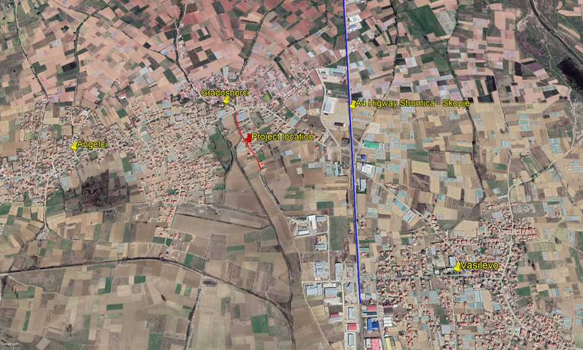
Figure 1 Location of the rehabilitation of the streets in Municipality of Vasilevo in s. “Gradasorci”
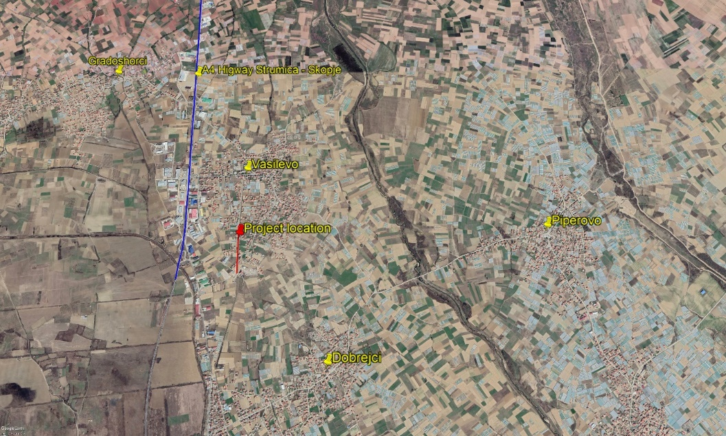
Figure 2 Location of the rehabilitation of the streets in Municipality of Vasilev, city of Vasilevo

ANNEX III: Report of the site visit of the reconstruction of the local streets in in s.“Gradasorci” and in s.“Vasilevo”

Reconstruction of the local street in s. “Gradasorci”
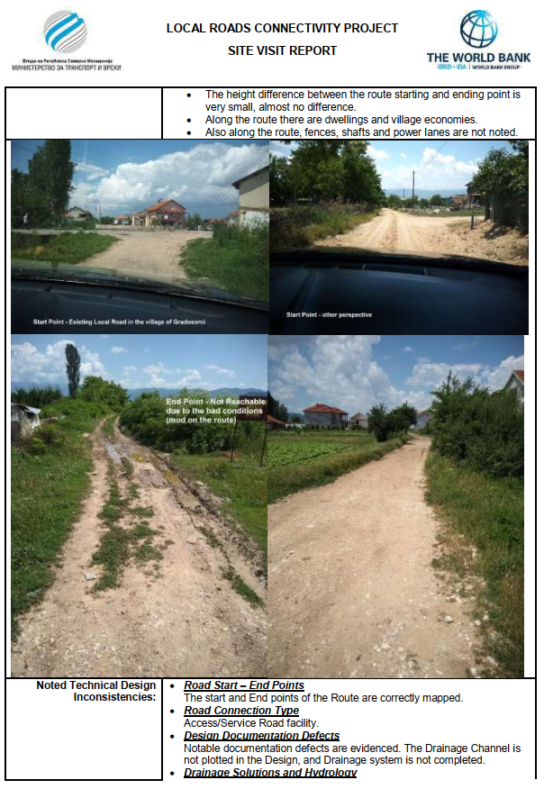
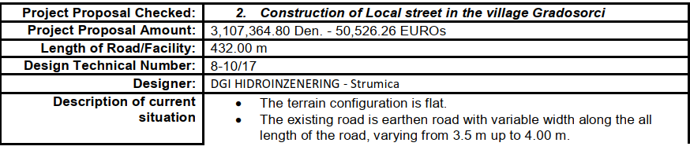
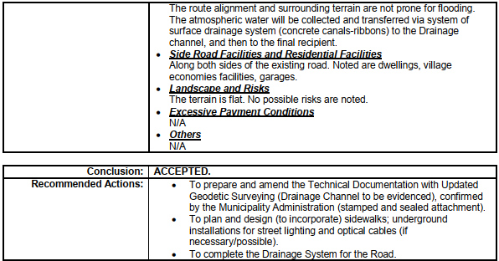

Reconstruction of the local street in s. “Vasilevo”
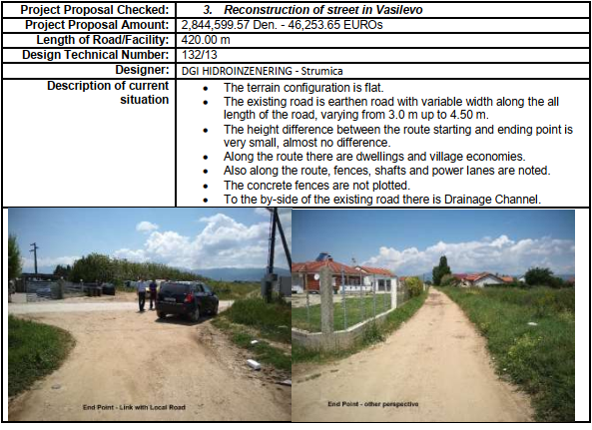
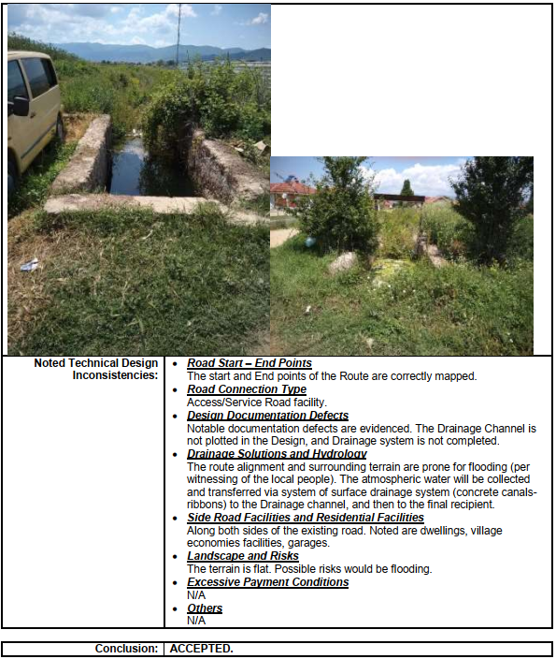
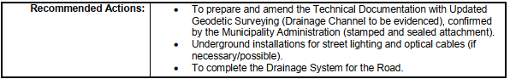

ANNEX IV: COVID-19 considerations in construction/civil works projects

Taking into account the new situation with the appearance of the virus COVID 19, besides the standard measures for safety and protection at work it is necessary to implement measures for protection from COVID 19.
Undoubtedly, the Contractors will face many challenges in the new situation, such as:
- Inability to purchase protective equipment and disinfectants due to lack on the market,
- Lack of labour due to limited movement and absences from work,
- Inability to provide materials and work equipment due to congestion in all segments of life in the country,
- Employees' concerns about their livelihoods due to reduced workload, etc.
First, it is necessary to implement the measures for protection from COVID 19 adopted by the Government of the Republic of Northern Macedonia at the proposal of the Commission for Infectious Diseases and the Ministry of Health. These measures should be constantly updated in accordance with the latest provisions introduced by the Government. The Contractor is required to nominate a responsible person who will follow the measures adopted by the Government and will apply them in the operation of the construction site at the project location.
Links of the national institutions responsible for COVID 19 where the Contractor could find updated information and recommendations:
- Government of the Republic of North Macedonia - https://vlada.mk/node/20488?ln=en-gb
- Ministry of Health - http://zdravstvo.gov.mk/korona-virus/
- Ministry of Labour and Social Policy - http://mtsp.gov.mk/covid-19.nspx
- Ministry of transport and communications - http://mtc.gov.mk/Preporaki%20od%20Vlada
- Official site for COVID – 19 - https://koronavirus.gov.mk/en
On national level in addition to the measures introduced by the Government for protection from COVID 19, the Macedonian Occupational Safety and Health Association developed a Guide to Safety and Health at Work in Construction Prevention from the Corona virus. The Guide contains measures that the Contractor is required to implement in order to eliminate the possible ways of obtaining and transmitting COVID 19 among the workers on construction site.
In more detail in several chapters, the Guide contains:
- Challenges in construction;
- Obligations for the Contractor;
- Obligations for workers;
- Liabilities for Investors;
- Ways of proceeding in cases of suspected case or cases infected with COVID 19;
- Contact phones of national institutions responsible for contacting the occurrence of the event infected with COVID 19.
The text of the Guide to Safety and Health at Work in Construction Prevention from the Corona virus on the Macedonian language is given on the following link
http://mzzpr.org.mk/wp-content/uploads/2020/04/covid19-%D0%B3%D1%80%D0%B0%D0%B4%D0%B5%D0%B6%D0%BD%D0%B8%D1%88%D1%82%D0%B2%D0%BE.pdf.
The Contractor also needs to implement the requirements introduced by the World Bank related to the protection of COVID 19.
Regarding the COVID-19 considerations in construction/civil works projects given by the World Bank, they are divided in several segments/issues and in details are shown on Table 1.

Table 1 COVID-19 considerations in construction/civil works projects recommended by WB
COVID-19 considerations in construction/civil works projects
Covid-19 issues | Type of activities
The Contractor should identify measures to address the COVID-19 situation taking into account the location, existing project resources, availability of supplies, capacity of local emergency/health services, the extent to which the virus already exist in the area.
PIU and Contractor should establish specific procedures for addressing COVID 19 issues on the construction site. Procedures should be implemented, documented and updated in accordance with the latest changes introduced by the Government and the conditions on the construction site.
Assessing workforce characteristics | • The Contractor should prepare a detailed profile of the project work force, key work activities, schedule for carrying out such activities, different durations of contract and rotations;  • This should include a breakdown of workers who reside at home (i.e. workers from the community), workers who lodge within the local community and workers in on-site accommodation (i.e. workers camp). Where possible, it should also identify workers that may be more at risk from COVID-19, those with underlying health issues or who may be otherwise at risk;  • Consideration should be given to ways in which to minimize movement in and out of site. This could include lengthening the term of existing contracts, to avoid workers returning home to affected areas, or returning to site from affected areas.
Entry/exit to the work site and checks on commencement of work | • Establishing a system for controlling entry/exit to the site, securing the boundaries of the site, and establishing designating entry/exit points (if they do not already exist). Entry/exit to the site should be documented;  • Training security staff on the (enhanced) system that has been put in place for securing the site and controlling entry and exit, the behaviors required of them in enforcing such system and any COVID -19 specific considerations;  • Training staff who will be monitoring entry to the site, providing them with the resources they need to document entry of workers, conducting temperature checks and recording details of any worker that is denied entry;  • Confirming that workers are fit for work before they enter the site or start work. While procedures should already be in place for this, special attention should be paid to workers with underlying health issues or who may be otherwise at risk. Consideration should be given to demobilization of staff with underlying health issues;  • Checking and recording temperatures of workers and other people entering the site or requiring self-reporting prior to or on entering the site;  • Providing daily briefings to workers prior to commencing work, focusing on COVID-19 specific considerations including cough etiquette, hand hygiene and distancing measures, using demonstrations and participatory methods;  • During the daily briefings, reminding workers to self-monitor for possible symptoms (fever, cough, and other respiratory symptoms) and to report to their supervisor or the COVID-19 focal point if they have symptoms or are feeling unwell;  • Preventing a worker from an affected area or who has been in contact with an infected person from returning to the site for 14 days or (if that is not possible) isolating such worker for 14 days;  • Preventing a sick worker from entering the site, referring them to local health facilities if necessary or requiring them to isolate at home for 14 days.
General hygiene | • Placing posters and signs around the site, with images and text in local languages (MK/ALB);  • Ensuring handwashing facilities supplied with soap, disposable paper towels and closed waste bins exist at key places throughout site, including at entrances/exits to work areas; where there is a toilet, canteen or food distribution, or provision of drinking water; in worker accommodation; at waste stations; at stores; and in common spaces. Where handwashing facilities do not exist or are not adequate, arrangements should be made to set them up. Alcohol based sanitizer (if available, 60-95% alcohol) can also be used;  - Training workers and staff on site on the signs and symptoms of COVID-19, how it is spread, how to protect themselves (including regular handwashing and social distancing) and what to do if they or other people have symptoms;  • Setting aside part of worker accommodation for precautionary self-quarantine as well as more formal isolation of staff who may be infected.
Cleaning and waste disposal | • Providing cleaning staff with adequate cleaning equipment, materials and disinfectant;  • Training cleaning staff on appropriate cleaning procedures and appropriate frequency in high use or high-risk areas;  • Where it is anticipated that cleaners will be required to clean areas that have been or are suspected to have been contaminated with COVID-19, providing them with appropriate PPE: gowns or aprons, gloves, eye protection (masks, goggles or face screens) and boots or closed work shoes. If appropriate PPE is not available, cleaners should be provided with best available alternatives;  • Training cleaners in proper hygiene (including handwashing) prior to, during and after conducting cleaning activities; how to safely use PPE (where required); in waste control (including for used PPE and cleaning materials);  • Any medical waste produced during the care of ill workers should be collected safely in designated containers or bags and treated and disposed of following relevant requirements (e.g., national - http://www.moepp.gov.mk/?nastani=%d0%bf%d1%80%d0%b5%d0%bf%d0%be%d1%80%d0%b0%d0%ba%d0%b8-%d0%b7%d0%b0-%d1%83%d0%bf%d1%80%d0%b0%d0%b2%d1%83%d0%b2%d0%b0%d1%9a%d0%b5-%d1%81%d0%be-%d0%be%d1%82%d0%bf%d0%b0%d0%b4-%d0%b7%d0%b0-%d0%b3%d1%80,  WHO). If open burning and incineration of medical wastes is necessary, this should be for as limited a duration as possible. Waste should be reduced and segregated, so that only the smallest amount of waste is incinerated.
Adjusting work practices | • Decreasing the size of work teams;  • Limiting the number of workers on site at any one time;  • Changing to a 24-hour work rotation;  • Adapting or redesigning work processes for specific work activities and tasks to enable social distancing, and training workers on these processes;  • Continuing with the usual safety trainings, adding COVID-19 specific considerations. Training should include proper use of normal PPE. While as of the date of this note, general advice is that construction workers do not require COVID-19 specific PPE, this should be kept under review;  • Arranging (where possible) for work breaks to be taken in outdoor areas within the site;  • Consider changing canteen layouts and phasing meal times to allow for social distancing and phasing access to and/or temporarily restricting access to leisure facilities that may exist on site, including gyms;  • At some point, it may be necessary to review the overall project schedule, to assess the extent to which it needs to be adjusted (or work stopped completely) to reflect prudent work practices, potential exposure of both workers and the community and availability of supplies, taking into account Government advice and instructions.
Project medical services | • Expanding medical infrastructure and preparing areas where patients can be isolated. Isolation facilities should be located away from worker accommodation and ongoing work activities. Where possible, workers should be provided with a single well-ventilated room (open windows and door). Where this is not possible, isolation facilities should allow at least 1 meter between workers in the same room, separating workers with curtains, if possible. Sick workers should limit their movements, avoiding common areas and facilities and not be allowed visitors until they have been clear of symptoms for 14 days. If they need to use common areas and facilities (e.g. kitchens or canteens), they should only do so when unaffected workers are not present and the area/facilities should be cleaned prior to and after such use.  • Training medical staff, which should include current WHO advice on COVID-19 and recommendations on the specifics of COVID-19. Where COVID-19 infection is suspected, medical providers on site should follow WHO interim guidance on infection prevention and control during health care when novel coronavirus (nCoV) infection is suspected;  • Assessing the current stock of equipment, supplies and medicines on site, and obtaining additional stock, where required and possible. This could include medical PPE, such as gowns, aprons, medical masks, gloves, eye protection, etc..;  • Review existing methods for dealing with medical waste, including systems for storage and disposal.
Local medical and other services | • Conducting preliminary discussions with specific medical facilities, to agree what should be done in the event of ill workers needing to be referred;  - Obtaining information as to the resources and capacity of local medical services (e.g. number of beds, availability of trained staff and essential supplies);  • Clarifying the way in which an ill worker will be transported to the medical facility, and checking availability of such transportation;  • Agreeing with the local medical services/specific medical facilities the scope of services to be provided, the procedure for in-take of patients and (where relevant) any costs or payments that may be involved;  • A procedure should also be prepared so that project management knows what to do in the unfortunate event that a worker ill with COVID-19 dies. While normal project procedures will continue to apply, COVID-19 may raise other issues because of the infectious nature of the disease. The project should liaise with the relevant local authorities to coordinate what should be done, including any reporting or other requirements under national law;
Instances or spread of the virus | • If a worker has symptoms of COVID-19 (e.g. fever, dry cough, fatigue) the worker should be removed immediately from work activities and isolated on site;  • The worker should be transported to the local health facilities to be tested (if testing is available and permitted under national legislation);  • If the test is positive for COVID-19 or no testing is available, the worker should continue to be isolated. This will either be at the work site or at home. If at home, the worker should be transported to their home in transportation provided by the project;  • Extensive cleaning procedures with high-alcohol content disinfectant should be undertaken in the area where the worker was present, prior to any further work being undertaken in that area. Tools used by the worker should be cleaned using disinfectant and PPE disposed of;  • Co-workers (i.e. workers with whom the sick worker was in close contact) should be required to stop work, and be required to quarantine themselves for 14 days, even if they have no symptoms;  • Family and other close contacts of the worker should be required to quarantine themselves for 14 days, even if they have no symptoms;  • If a case of COVID-19 is confirmed in a worker on the site, visitors should be restricted from entering the site and worker groups should be isolated from each other as much as possible;  • If workers live at home and has a family member who has a confirmed or suspected case of COVID-19, the worker should quarantine themselves and not be allowed on the project site for 14 days, even if they have no symptoms;  • Workers should continue to be paid throughout periods of illness, isolation or quarantine, or if they are required to stop work, in accordance with national law;  • Medical care (whether on site or in a local hospital or clinic) required by a worker should be paid for by the employer.
Continuity of supplies and project activities | • Identify back-up individuals, in case key people within the project management team (PIU, Supervising Engineer, Contractor, sub-contractors) become ill, and communicate who these are so that people are aware of the arrangements that have been put in place;  • Document procedures, so that people know what they are, and are not reliant on one person’s knowledge;  • Understand the supply chain for necessary supplies of energy, water, food, medical supplies and cleaning equipment, consider how it could be impacted, and what alternatives are available. Early pro-active review of international, regional and national supply chains, especially for those supplies that are critical for the project, is important (e.g. fuel, food, medical, cleaning and other essential supplies). Planning for a 1-2 month interruption of critical goods may be appropriate for projects in more remote areas;  • Place orders for/procure critical supplies. If not available, consider alternatives (where feasible);  • Consider existing security arrangements, and whether these will be adequate in the event of interruption to normal project operations;  • Consider at what point it may become necessary for the project to significantly reduce activities or to stop work completely, and what should be done to prepare for this, and to re-start work when it becomes possible or feasible.
Contingency planning for an outbreak | The contingency plan to be developed at each site should set out what procedures will be put in place in the event of COVID-19 reaching the site. The contingency plan should be developed in consultation with national and local healthcare facilities and follow state guidance for COVID-19 response, to ensure that arrangements are in place for the effective containment, care and treatment of workers who have contracted COVID-19. The contingency plan should also consider the response if a significant number of the workforce become ill, when it is likely that access to and from a site will be restricted to avoid spread.  Contingencies should be developed and communicated to the workforce for:  • Isolation and testing procedures for workers (and those they have been in contact with) that display symptoms;  • Care and treatment of workers, including where and how this will be provided;  • Getting adequate supplies of water, food, medical supplies and cleaning equipment in the event of an outbreak on site, especially should access to the site become restricted or movements of supplies limited.  Specifically, the plan should set out what will be done if someone may become ill with COVID-19 at a worksite. The plan should:  • Set out arrangements for putting the person in a room or area where they are isolated from others in the workplace, limiting the number of people who have contact with the person and contacting the local health authorities;  • Consider how to identify persons who may be at risk (e.g. due to a pre-existing condition such as diabetes, heart and lung disease, or as a result of older age), and support them, without inviting stigma and discrimination into your workplace; and  • Consider contingency and business continuity arrangements if there is an outbreak in a neighboring community.  Contingency plans should consider arrangements for the storage and disposal arrangements for medical waste, which may increase in volume and which can remain infectious for several days (depending upon the material). The support that site medical staff may need, as well as arrangements for transporting (without risk of cross infection) sick workers to intensive care facilities or into the care of national healthcare facilities should be discussed and agreed.  Contingency plans should also consider how to maintain worker and community safety on site should sites closed to comply with national or corporate policies, should work be suspended or should illness affect significant numbers of the workforce. It is important that worksite safety measures are reviewed by a safety specialist and implemented prior to work areas being stopped.
Training and communication with workers | • Regular information and engagement with workers (e.g. through training, town halls, tool boxes) that emphasizes what management is doing to deal with the risks of COVID-19. Workers should be given an opportunity to ask questions, express their concerns, and make suggestions;  • Training should address issues of discrimination or prejudice if a worker becomes ill and provide an understanding of the trajectory of the virus, where workers return to work;  • Training should cover all issues that would normally be required on the work site, including use of safety procedures, use of construction PPE, occupational health and safety issues, and code of conduct, taking into account that work practices may have been adjusted;  • Communications should be clear, based on fact and designed to be easily understood by workers, for example by displaying posters on handwashing and social distancing, and what to do if a worker displays symptoms.
Communication and contact with the community | • Communications should be clear, regular, based on fact and designed to be easily understood by community members;  • Communications should utilize available means. In most cases, face-to-face meetings with the community or community representatives will not be possible. Other forms of communication should be used; online platforms, social media, posters, pamphlets, radio, text messages, virtual meetings. The means used should take into account the ability of different members of the community to access them, to make sure that communication reaches these groups;  • The community should be made aware of procedures put in place at site to address issues related to COVID-19. This should include all measures being implemented to limit or prohibit contact between workers and the community. The community should be made aware of the procedure for entry/exit to the site, the training being given to workers and the procedure that will be followed by the project if a worker becomes sick.
Covid-19 reporting | The contractor should report a work stoppage as a consequence of reported sick workers from KOVID 19. The Contractor should keep the Borrower informed of any concerns or problems associated with providing care to infected workers on project sites, particularly if infection rate is approaching 50% of the workforce.

ANNEX V: Form for submitting comments
Form for submitting comments and suggestions for ESMP Checklist Rehabilitation of the existing local streets, in s.“Gradasorci” and in s.“Vasilevo” Municipality of Vasilevo
Main description of the project
The local streets for upgrading are located in the Municipality Vasilevo, more precisely in the s.“Gradasorci” and in s.“Vasilevo”. The length of the sub project street in s.“Gradasorci” is 432 m with a width of the road of 3,5 m. The length of the sub project street in s.“Vasilevo” is 420 m with a width of the road of varying from 3,5 - 5 m. The main activities on both roads will include: marking and securing the routes at the project locations, placing new tampon layer of crushed stone and placing bearing bitumen asphalt layer and in the s. “Vasilevo” constructing a retaining wall.

Electronic version of ESMP Checklist Rehabilitation of the existing local streets, in s.“Gradasorci” and in s.“Vasilevo” Municipality of Vasilevo is available on:
- Municipality of Vasilevo: http://opstinavasilevo.gov.mk/
- MoTC PIU: http://mtc.gov.mk/

Name and surname of the person who provides comment*

Contact information* | E-mail:  ______________________________  Phone:  ______________________________
Comment on the ESMP Checklist:

Signature  ______________________ |  | Date  ____________________
If you have any comments/suggestions or amendments to the proposed measures of ESMP Checklist Rehabilitation of the existing local streets, in s.“Gradasorci” and in s.“Vasilevo” Municipality of Vasilevo, please submit it to the responsible persons from the following institution:
- Project Office WB (web page)
Contact Person: Irena Paunovikj
e-mail: irena.paunovikj.piu@mtc.gov.mk

Within the 14 days period after the announcement of ESMP Checklist Rehabilitation of the existing local streets, in s.“Gradasorci” and in s.“Vasilevo” Municipality of Vasilevo
(date of announcement: ……. )
Referent number: ______________________________
(fulfilled by the responsible persons for the project implementation)
* Fulfillment of the fields with personal data is not obligatory

ANNEX VI: Grievance Form for whole project implementation period
Reference Number
Full name (optional)
- I wish to raise my grievance anonymously.
- I request not to disclose my identity without my consent.
Contact information  Please mark how you wish to be contacted (by post, telephone, e-mail). | - By Post: Please provide mailing address:  ________________________________________________________________________________________________________________________________________________________________________  - By telephone: ___________________________________________________  - By E-mail
Preferred language of communication | - Macedonian  - Albanian  - Turkish  - Other: ____________________
Gender | - Female  - Male
Description of Incident for Grievance |  | What happened? Where did it happen? Whom did it happen to? What is the result of the problem?
Date of Incident / Grievance
- One-time incident/grievance (date ________________)
- Happened more than once (how many times? ______)
- On-going (currently experiencing problem)
What would you like to see happen?
Signature: _______________________________
Date: _______________________________
Please return this form to:

Name and surname | Irena Paunovikj | Goran Andonov
E-mail / phone | irena.paunovikj.piu@mtc.gov.mk | andonov_goran1990@yahoo.com
Institution | Ministry of Transport and communications | Municipality of Vasilevo | Contractor Company

Local Roads Connectivity Project
St. Dame Gruev 6,1000 Skopje, R. N. Macedonia

Toxic/hazardous materials include but not limited to fuels, motor/hydraulic oils, lubricants, toxic paints, etc.
Land acquisition covers people's displacement, lifestyle changes, disturbance of private ownership and affecting people living and / or staying or running a business (kiosks) on the land or nearby

